Images used in presentation:
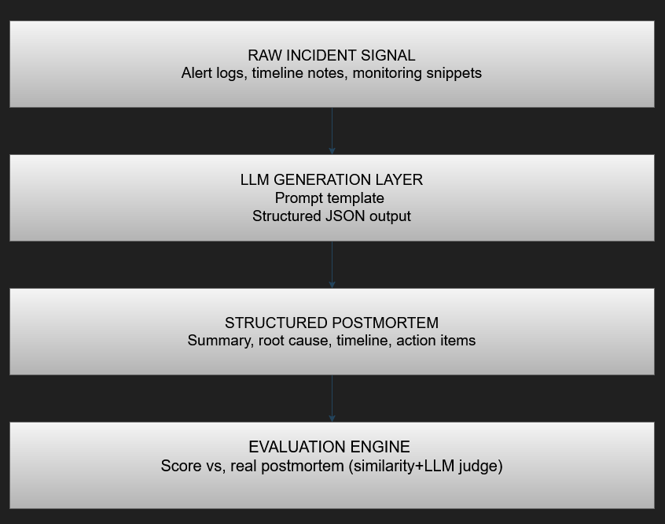
Each incident flows through four stages: from raw signal to a scored, structured postmortem ;giving both a usable draft and a measurable quality benchmark.

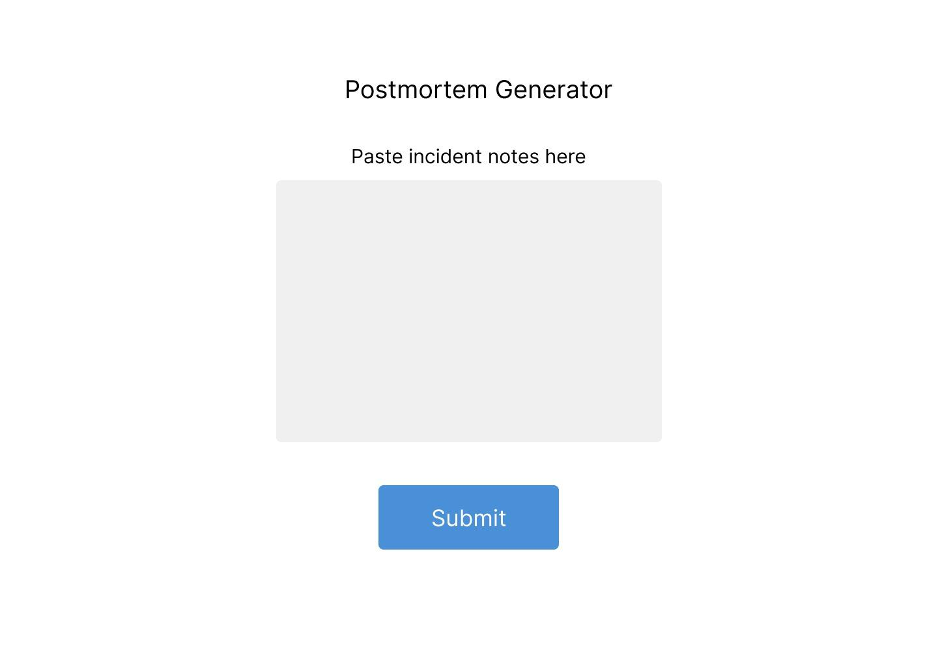
INPUT SCREEN
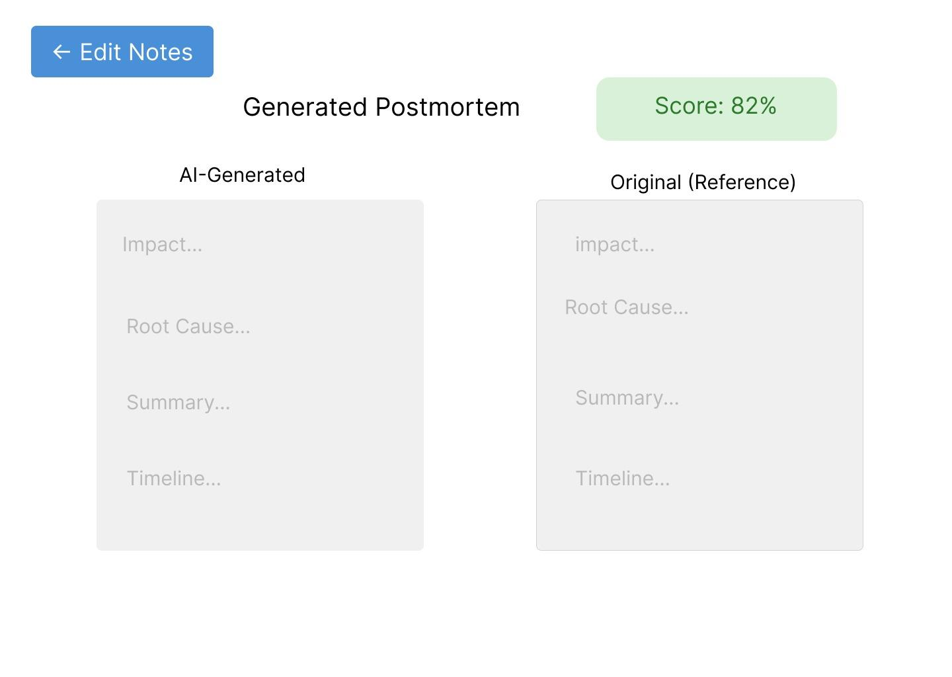
OUTPUT SCREEN

